**Placement Cell Report 2024-2025**

**G.G.J. Government College, Hisar**

1. **11 January, 2025: Axis Bank Assistant Manager Placement Drive**

On 11th January, 2025 an “Axis Bank Assistant Manager Placement Drive” was organized by placement cell of GGJ Government college, Hisar in collaboration with NIIT. This event was inaugurated by the principal of the college Dr. Vivek Saini and convener of the placement cell Dr. Satish Kumar. In this placement drive, a skill lecture was also organised before the interview session for providing student the valuable insights and practical skills. Total 46 students of our college participated in the drive and 02 students were selected for the training as well as offered job after the training.

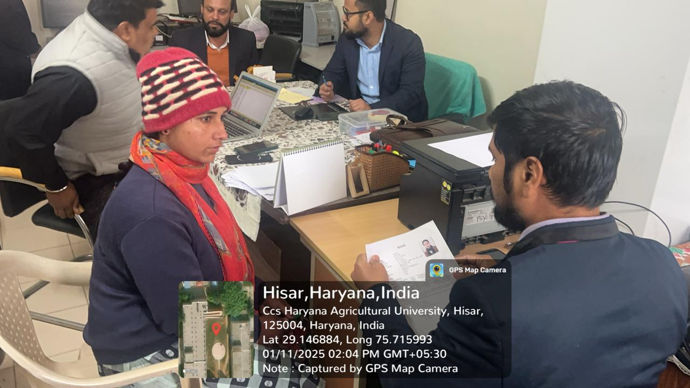

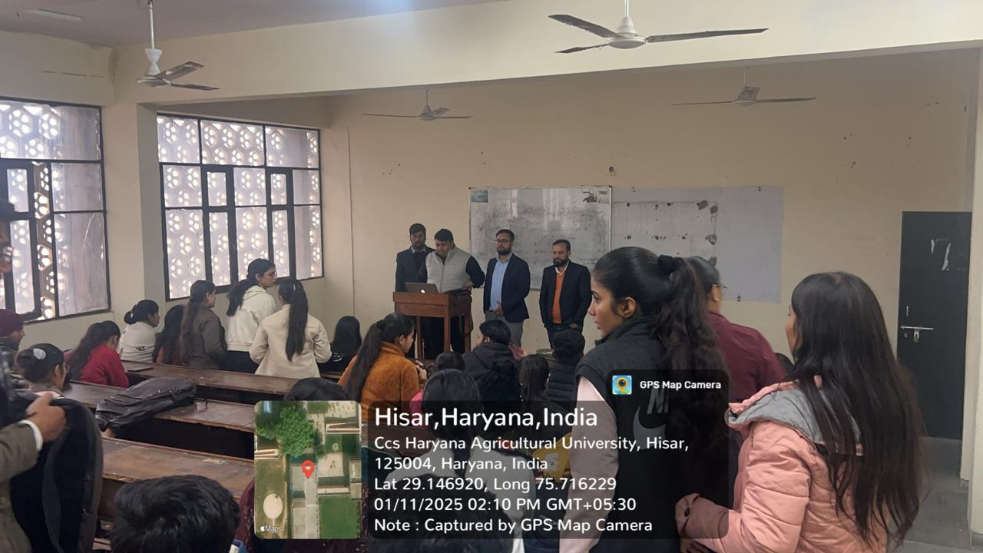

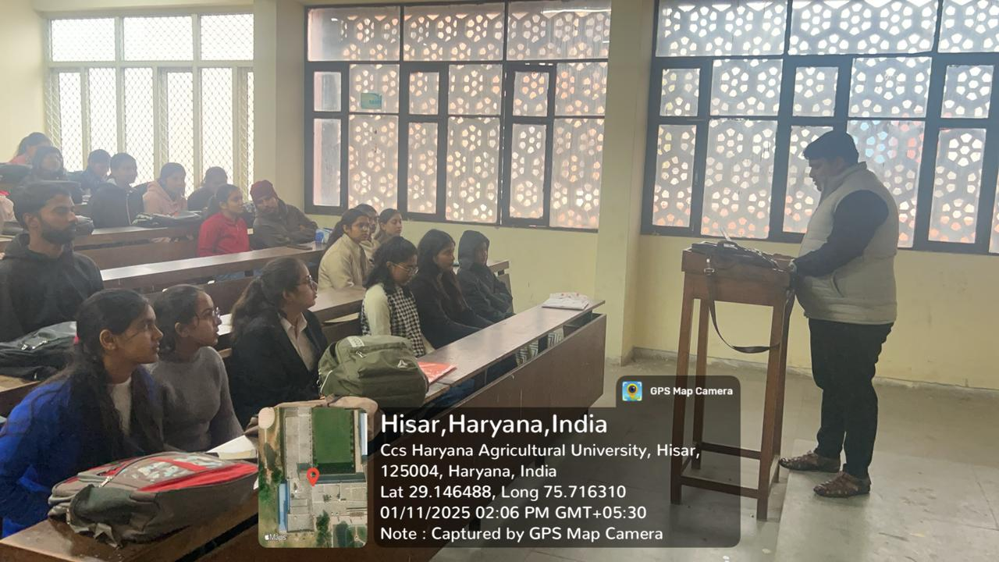

1. **25 January, 2025: MoU with Digital Chaabi Academy, Hisar**

GGJ Govt. College Hisar has signed a Memorandum of Understanding (MoU) with Digital Chaabi Academy, Hisar to enhance skill development, provide great exposure and create new learning opportunities for students. This collaboration aims to bridge the gap between academia and industry and preparing the college students for digital marketing field.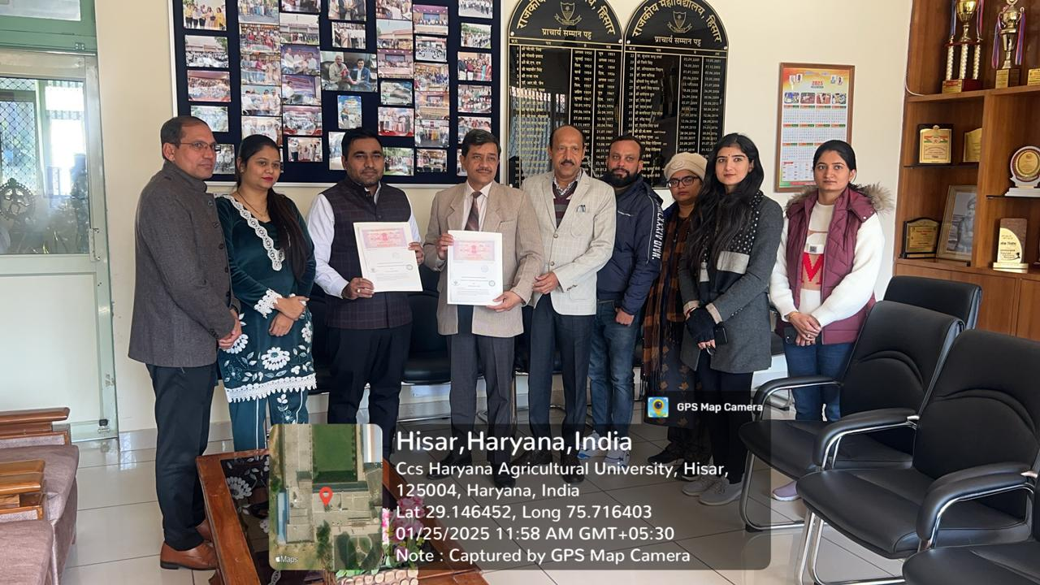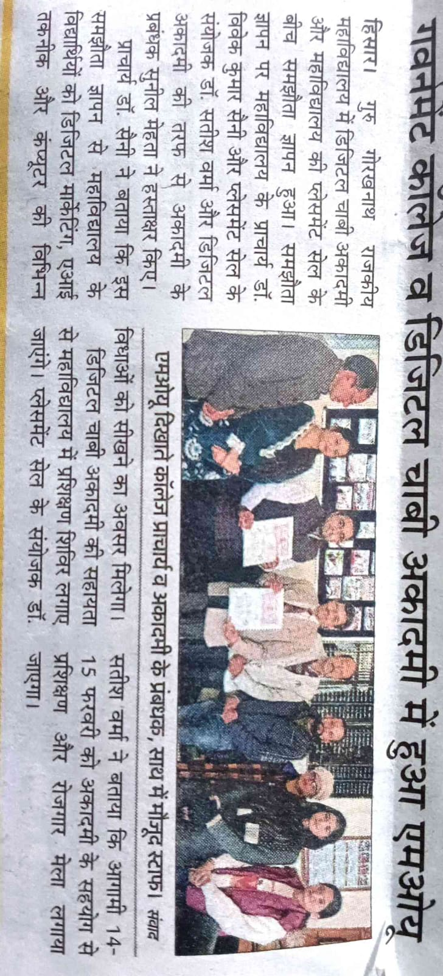

1. **07 February, 2025: MoU with NCSC** **for SC/STs, Hisar, Govt. of India.**

GGJ Govt. College, Hisar has signed a Memorandum of Understanding (MoU) with NCSC for SC/STs, Hisar, Ministry of Labour and Employment, Govt. of India. It will provide opportunity to students to get the training to face the interview, to enhance skills and expertise in high demand areas. This collaboration aims to promote innovations, entrepreneurship and technology transfer with industry.

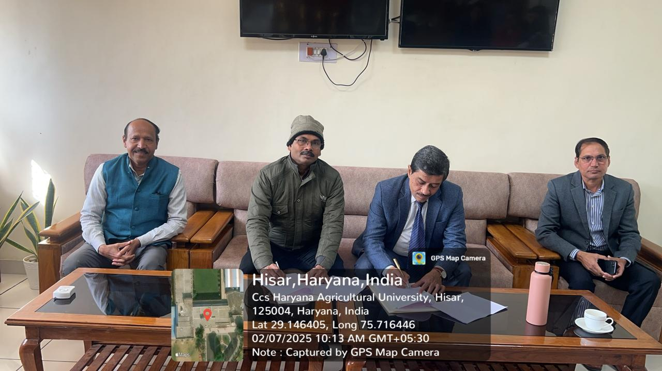

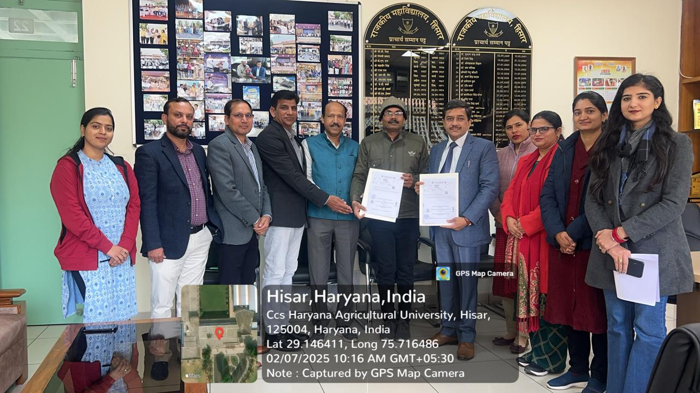

1. **14-15th February, 2025: Employability Training and Placement Fair**

On 14-15th February, 2025 an “Employability Training and Placement Fair” was organized by placement cell of Government college, Hisar in collaboration with NCSC and Digital Chaabi Academy, Hisar. Employability training on 14th February, 2025 was inaugurated by Dr. Ramesh Arya (Ex-Principal, GCW Hisar) and he emphasized on skill enhancement. Training was conducted in 4 sessions by resource persons who delivered their talk on job opportunities in Digital Marketing, Chat GPT, Graphic Designing and Information Technology.

Placement Fair was inaugurated by Dr. G. S. Chauhan ( Joint Secretary, UGC) and principal of the college Dr. Vivek Saini on 15th February, 2025. In this Placement Fair, total 228 students from various colleges of Hisar division participated and taken the interview for placement. Total 23 companies from different sectors conducted the interview for participants. 78 students were selected for the next step of job by the employers.

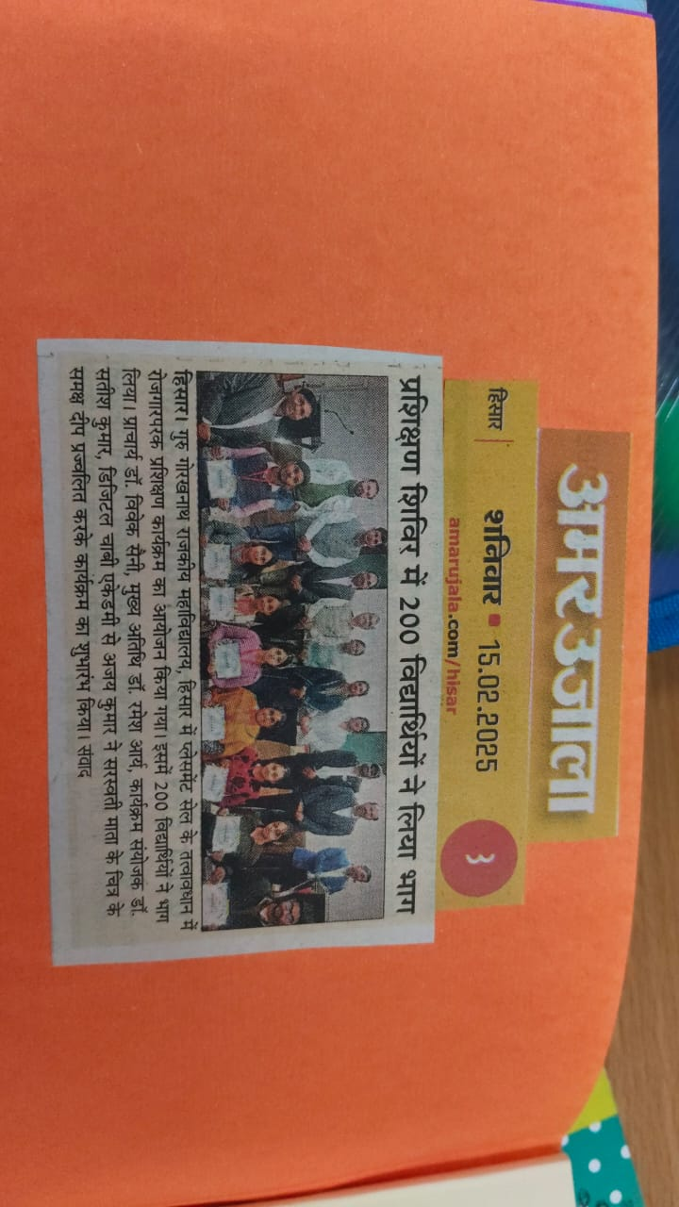

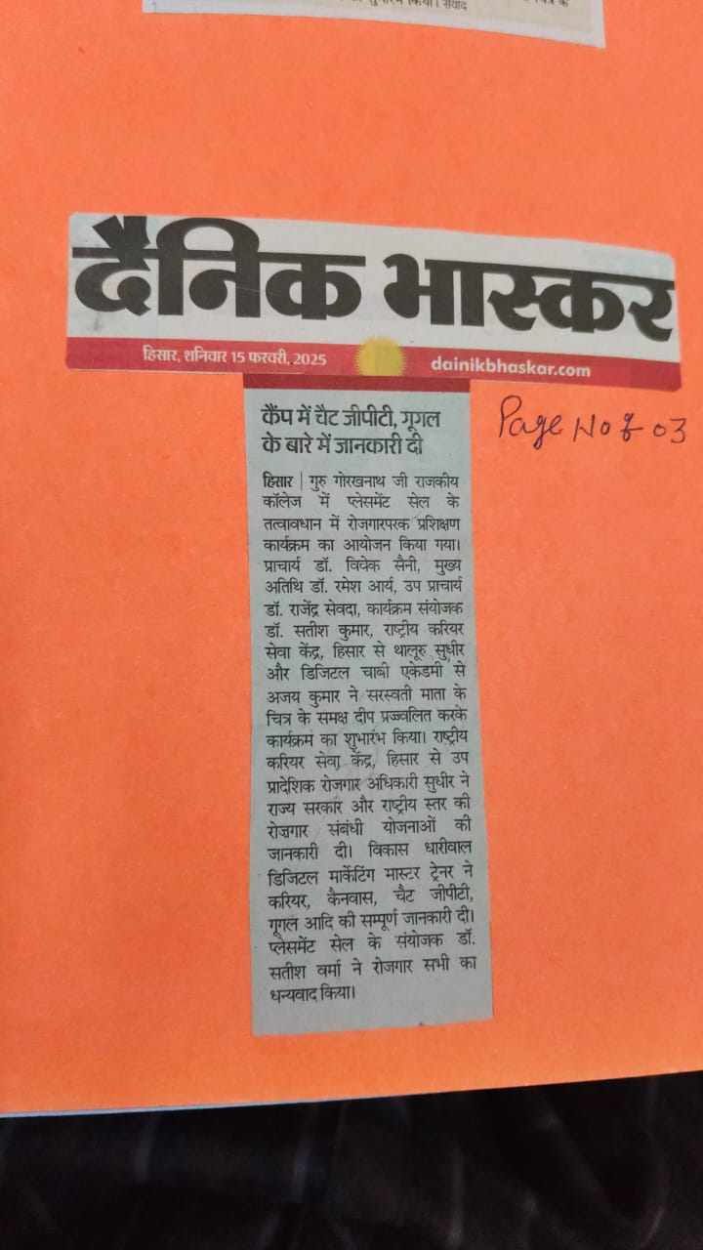

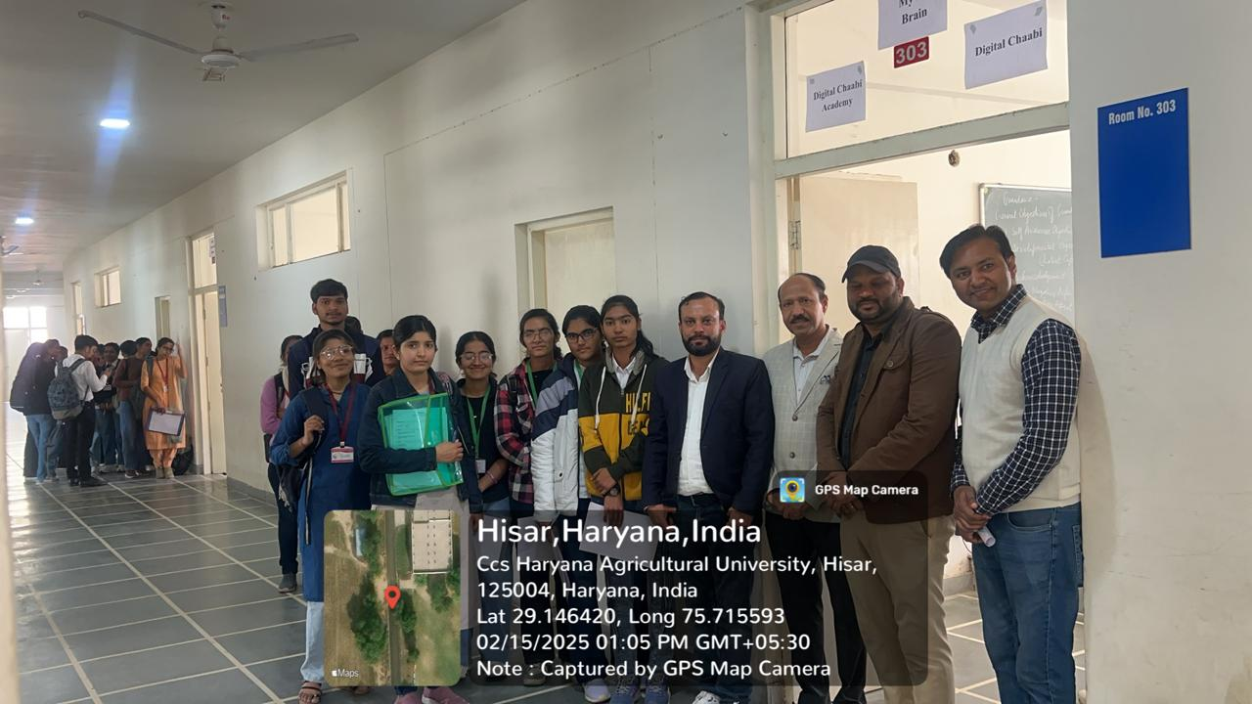

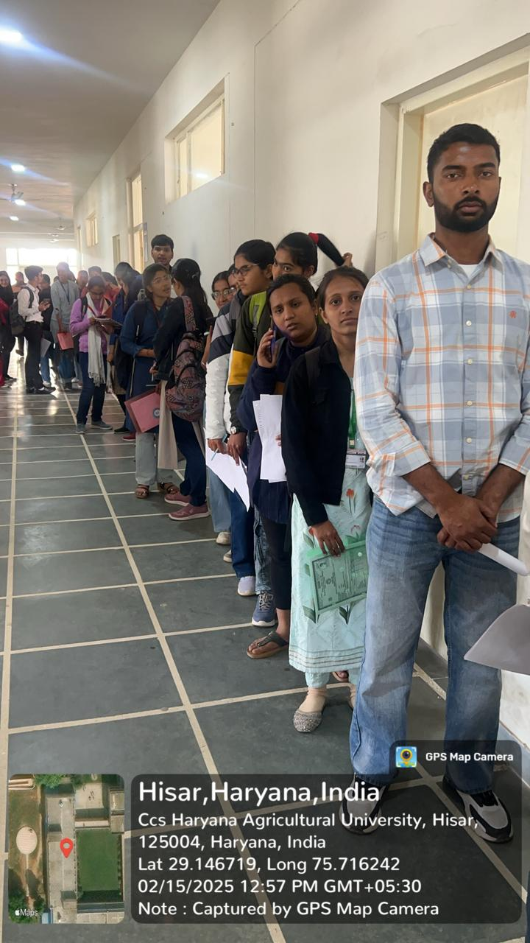

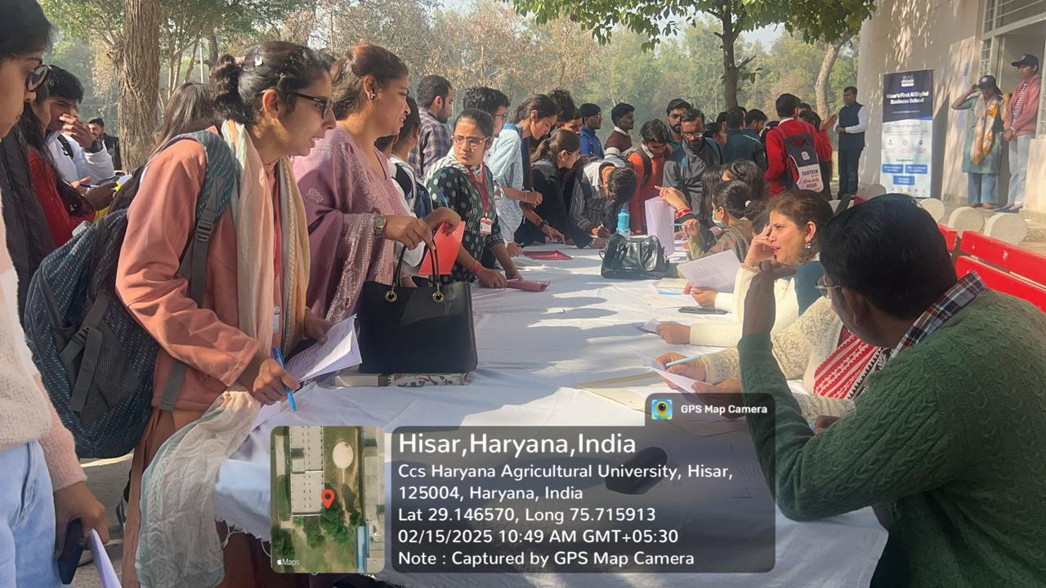

1. **9 April, 2025: Placement Drive with Amar Ujala, Hisar.**

Amar Ujala Newspaper Team of Hisar conducted a Placement Test in which total 93 students appeared. Students were provided the career guidance about opportunities of job in Media.

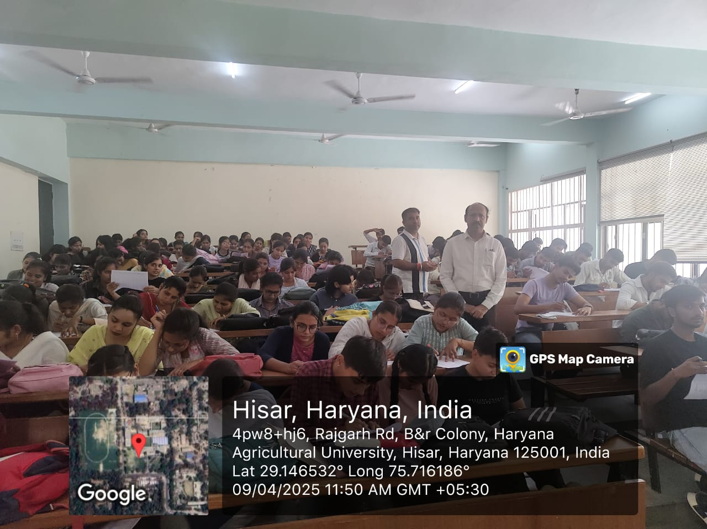

1. **11 April, 2025: MoU with Management Infotech System, Rampura Mohalla, Hisar.**

GGJ Govt. College, Hisar has signed a Memorandum of Understanding (MoU) with Management Infotech System, Rampura Mohalla, Hisar. It will provide opportunity to students to get the training of Mock Interview, Career Guidance and Computer Courses. This collaboration aims to promote innovations, entrepreneurship and technology transfer with industry.

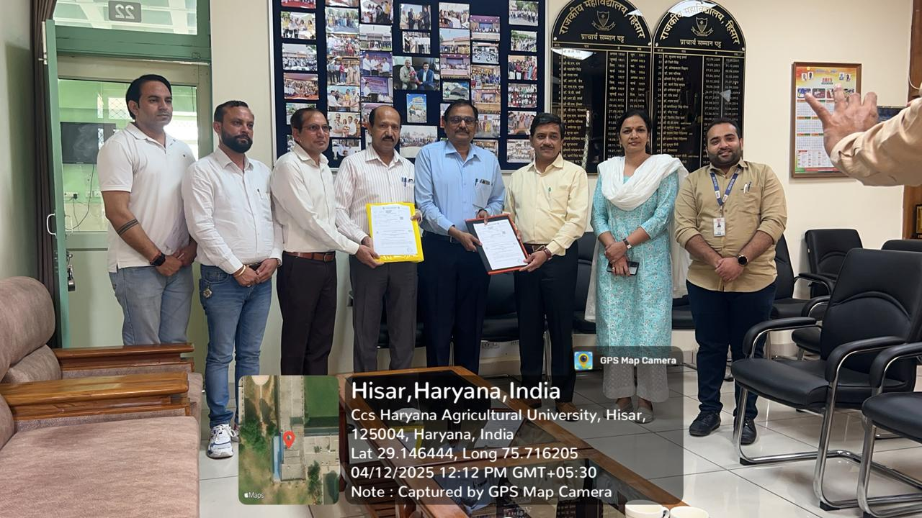

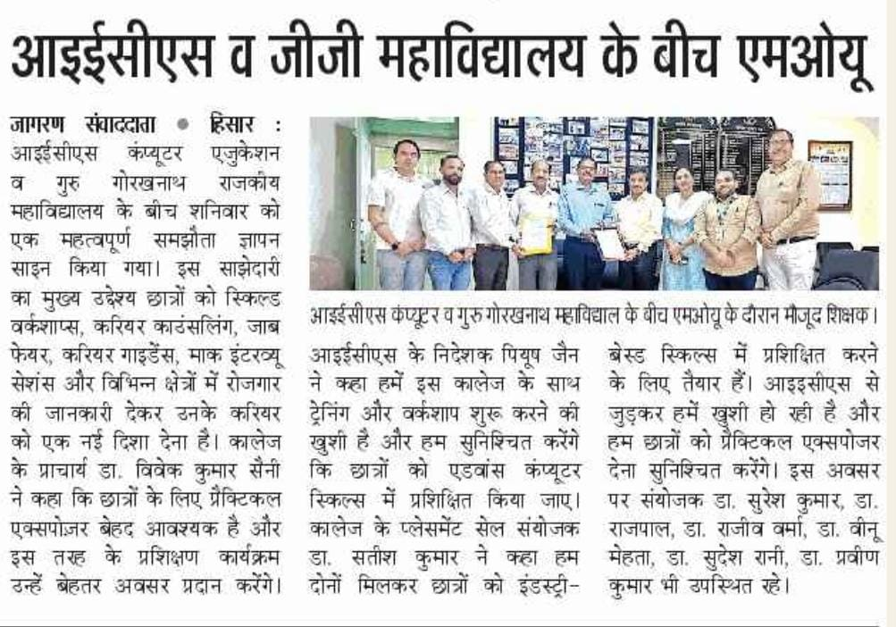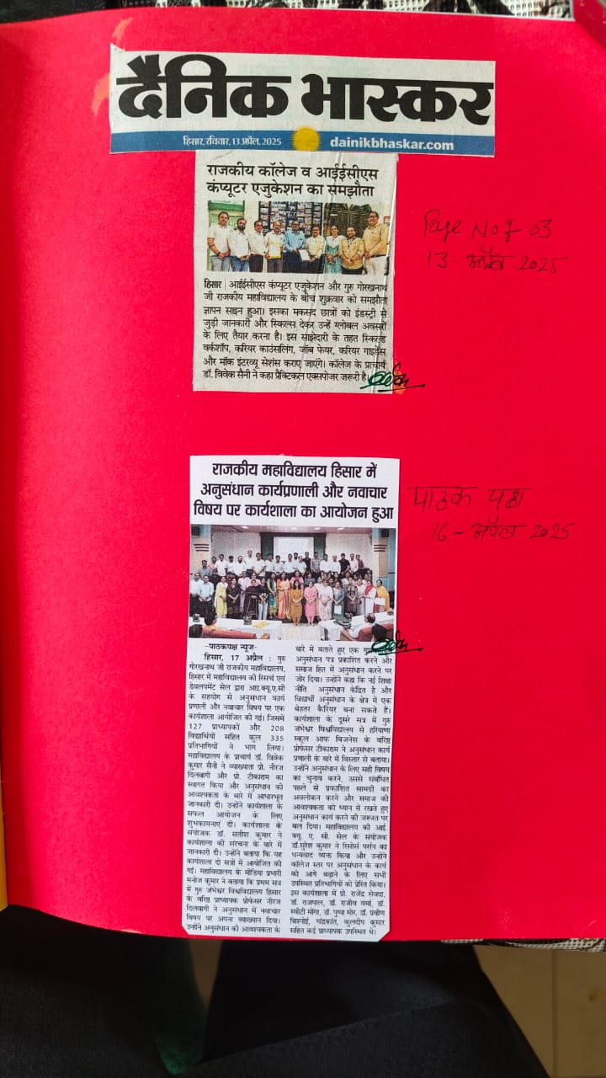

1. **18-19th April, 2025: Two Days Workshop on Digital Marketing.**

The Placement Cell of G.G.J. Government College, Hisar in collaboration with the Ratan Tata Commerce Society organized a Two-Day Workshop on Digital Marketing on 18th and 19th April 2025 in the College Auditorium. The event was held to mobilise the students about practical utilization of Digital Marketing. Resource persons from Digital Chabbi Academy, Hisar, Dr. Sagar Kathuria and Dr. Sadhna Mehta conducted sessions on Website Hosting, SEO, and SEM, explaining both theory and practical applications. Students actively participated and interacted with the experts. On the concluding day, Dr. Satish Verma appreciated the efforts of the organizers and motivated students to strengthen their digital skills. Scholarships and prizes were also distributed to meritorious students.

